JComboBox

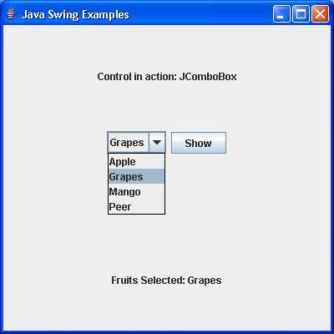

Ex:

String pl[]={“C”,”CPP”,”JAVA”,”PHP”};

JComboBox cb=new JComboBox(pl);

Cb.setEditable(true); // for make it Editable

Various Methods of JComboBox:-

* setSelectedIndex(int index)
* setSelectedItem(Object)
* addItem(Object)
* removeItemAt(int index)
* removeItem(object)
* removeAllItems()
* int getItemCount()